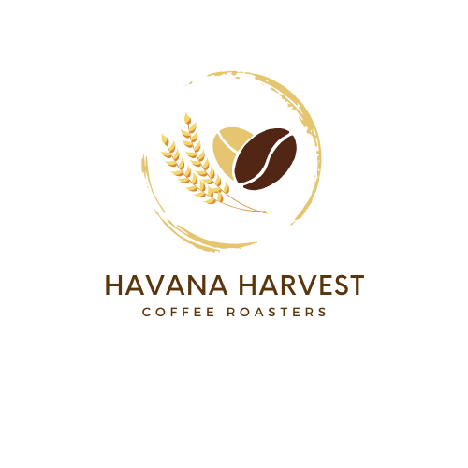
COFFEE, TEA AND HOT CHOCOLATE SERVICE
100% fair trade organic coffee, assorted herbal teas and gourmet hot chocolate. Service includes cups, stirrers, dairy creamers, and assorted sweeteners.
Almond, Oat and Soy Milk available, upon request, for an upcharge.
BEVERAGE DISPENSER OPTIONS*:
Indoor Events Only
3 Gal GOLD TRIM COFFEE CHAFER URN (Serves 35 - 55) $175
For weddings, galas, and other upscale events

45 CUP URN (serves 15 - 30) $75
110 CUP URN (serves 45 - 65) $125

Indoor and Outdoor Events
JOE TO GO DISPOSABLE BOX (serves 10 - 12) $35
THERMAL AIR POT (serves 12 - 15) $40
2.5 GALLON INSULATED DISPENSER (serves 30 - 45) $75

COFFEE SELECTIONS*
organic or fair trade house blend regular (light, medium, medium dark and dark roast), organic house blend decaf, Italian roast, french vanilla, hazelnut, vanilla bean creme brulee, vanilla macadamia, brown sugar bourbon, maple praline and caramel truffle.
TEA SELECTIONS*
Breakfast Blend, Lavender, Berry Blend, Jasmine and Assorted.

HOT CHOCOLATE SELECTIONS* $75
French Vanilla, Salted Caramel, White Chocolate, and Milk Chocolate

HAVANA COFFEE CONTINENTAL BREAKFAST* (serves 50) $400
Assortment of freshly baked muffins, cinnamon rolls, bagels, scones, croissants, and fresh fruit. Includes, cream cheese, assorted jelly, butter. Beverage Bar: Coffee, Hot Water & Assorted Tea, Juice and Water. (can be customized for any event)
PASTRIES - select three (serves 24) $150
Muffins - blueberry muffin, morning glory muffin, apple cinnamon muffin
Sweet Breads - banana bread, apple fritter bread, cinnamon brown sugar bread
Other Pastries: apple turnovers, cream cheese danish, berry danish, cinnamon roll

NIBBLER BASKET
Bite-size cookies, dessert bars, brownies and muffins beautifully arranged with fresh seasonal fruit
Small Basket (28 pieces) $75
Large Basket (56 pieces) $150
COOKIE PLATTER (choose 4 flavors)
Assortment of freshly baked gourmet cookies: peanut butter, oatmeal raisin, chocolate chip, lemon, white chocolate macadamia, and sugar.
Half Dozen $45
Dozen $55

AL A CARTE
Assorted Fresh Muffins - Half Dozen $35
Cinnamon Rolls - Half Dozen $40
Assorted Danishes - Half Dozen $35
Apple Turnovers - Dozen $40
Fresh Fruit Platter - Serves 12 $75

Gluten free cookies, dessert bars and brownies are available to include in baskets/platters, for an additional charge, with 48 hour notice.
*Includes cups, stirrers, napkins, sweeteners and creamers

